OpenMoko Main Menu Desktop

Layout Components
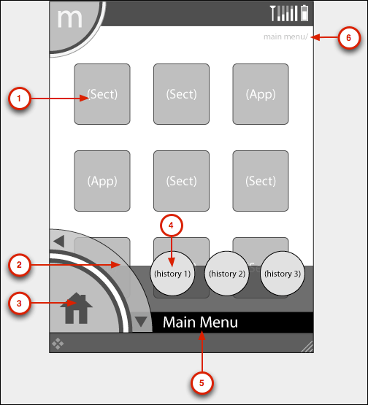

Q1: The main menu launch in finger mode is hard to implement, because it’s height is outside top-panel’s height.

Q2: As before, main menu desktop will be included six (2x3) sections or applications, not nine (3x3). I suggest refer to 2x3.

Q3: Refer to layout definition, it has shadow effect. If we program based matchbox-desktop, it is hard to implement. Matchbox-desktop is based Xlib programming.

Q4: Please define our all application’s .desktop and .directory files.

Architectural Details
- This picture shows an overview about the main menu desktop application.
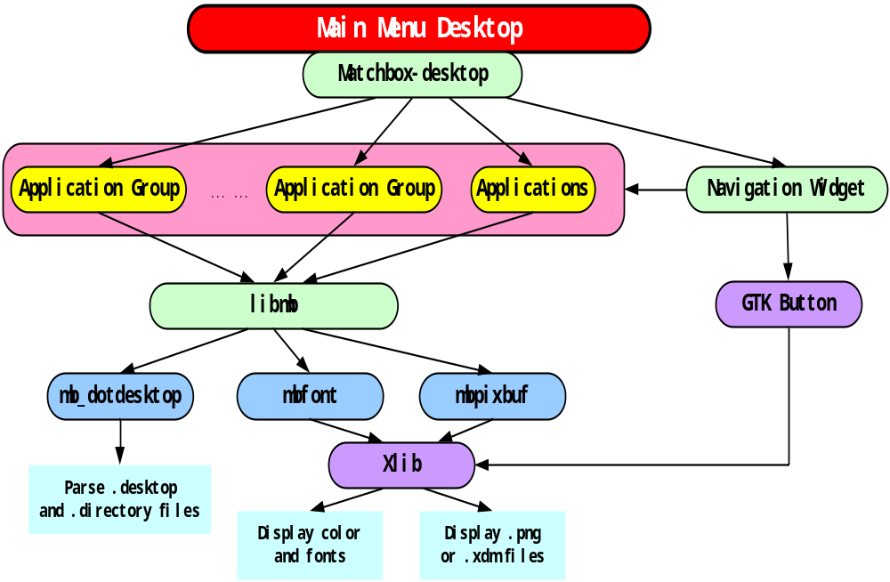

Implementation Recommendation
- It will be a freedesktop standard desktop application, displayed with full screen.

- Matchbox-desktop application is a good idea. It can be as main menu desktop base implementation. We need to as following:
  - Modify row and column of each screen to 2x3 mode.
  - Add a navigation wheel in button of desktop to operation (up/down) section or application.
  - Add three history application link to main menu desktop
  - Add top with hold event in application to popup launch menu, it has three functions:
      - Execute Application
      - Add To Launch
      - Remove From Launch
  - Add to display current section name in the bottom of desktop.
  - Add to display application path in the top-right of desktop
  - Add to display back level in the bottom-left of desktop

- All “Application Group” and “Application” are depended .desktop and .directory files. Group name is decided by “Category” section in .desktop files. They are usually included in “/usr/share/applications” directory. Libmb has provided some APIs to parse .desktop files.

- All icons and fonts will be displayed by mbfont and mbpixbuf from Libmb library.

Interface Introduce
- Inside Interface
  - Libmb
      - mbdotdesktop API (Freedesktop Standards utility)
      - mbpixbuf API
      - mbfont API

  - Navigation wheel widget
We shall use some .png file (up/down/back). They are displayed on main menu desktop by mbpixbuf API.
  - Previous button
【On Tap】
- Scroll up section or application one row. If no more, refresh desktop.
【Other】
        - In popup mode, to close popup menu, refresh desktop
        - Not in popup mode, nothing to do
  - Next button
【On Tap】
- Scroll down section or application one row. If no more, refresh desktop.
【Other】
        - In popup mode, to close popup menu, refresh desktop
        - Not in popup mode, nothing to do
  - Back button
【On Tap】
- back to level. If no more, refresh desktop.
【Other】
        - In popup mode, to close popup menu, refresh desktop
        - Not in popup mode, nothing to do

  - Desktop Item widget
We shall use some .png file (folder/application). They are displayed on main menu desktop by mbpixbuf API. And we render some font to desktop.
  - Folder Item
【On Tap】
        - In popup mode, to close popup menu, refresh desktop.
        - Not in popup mode, entry one folder, and display sub-level. The first section or application will be highlight.
        - The item will be highlight.
        - Refresh current section name
        - Refresh current section or application path
【Other】
        - In popup mode, to close popup menu, refresh desktop.
        - Not in popup mode, nothing to do.
        - The item will be highlight.
        - Refresh current section name
        - Refresh current section or application path
  - Application Item
【On Tap】
        - In popup mode, to close popup menu, refresh desktop.
        - Not in popup mode, launch application directly. Refresh history application list.
        - The item will be highlight
        - Refresh current section name
        - Refresh current section or application path.
【On Tap with Hold】
        - In popup mode, to close old popup menu and open a new popup menu.
        - Not in popup mode, to open a new popup menu.
        - The item will be highlight.
        - Refresh current section name
        - Refresh current section or application path
【Other】
        - In popup mode, to close popup menu, refresh desktop.
        - Not in popup mode, nothing to do.

  - Desktop History widget
We shall use some .png file (three latest applications). They are displayed on main menu desktop by mbpixbuf API. And we render some font to desktop.
  - History Application button
【On Tap】
        - In popup mode, to close popup menu, refresh desktop.
        - Not in popup mode, to launch one history application.
【Other】
        - In popup mode, to close popup menu, refresh desktop.
        - Not in popup mode, nothing to do.

  - Popup menu widget
We shall use some .png file (three latest applications). They are displayed on main menu desktop by mbpixbuf API. And we render some font to desktop.
  - Menu – ‘Execute Application’
【On Tap】
        - Execute the application.
        - Close the popup menu.
        - Refresh the desktop.
【Other】
        - Nothing to do.
  - Menu – ‘Add To Launch’
【On Tap】
        - Add the application to quick launch list
        - Close the popup menu.
        - Refresh the desktop.
【Other】
        - Nothing to do.
  - Menu – ‘Remove From Launch’
【On Tap】
        - Remove the application from quick launch list
        - Close the popup menu.
        - Refresh the desktop.
【Other】
        - Nothing to do.

- Outside Interface
  - ‘_MB_THEME_’ Xlib property event.
If we switch a matchbox theme. we shall modify a Xlib property atom named ‘_MB_THEME_’.

  - Display main menu desktop on top of screen via matchbox window-manager.

  - dbus
  - notify footer menu information status

Flow Chart
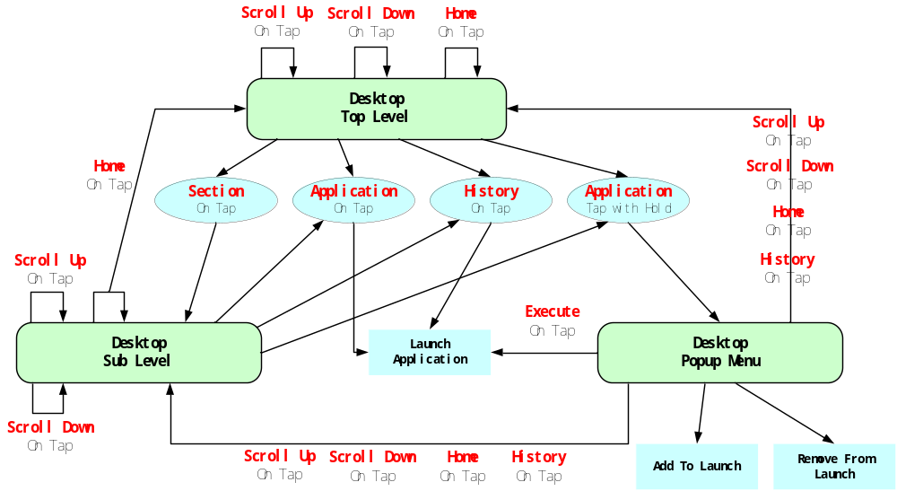
Image Resources
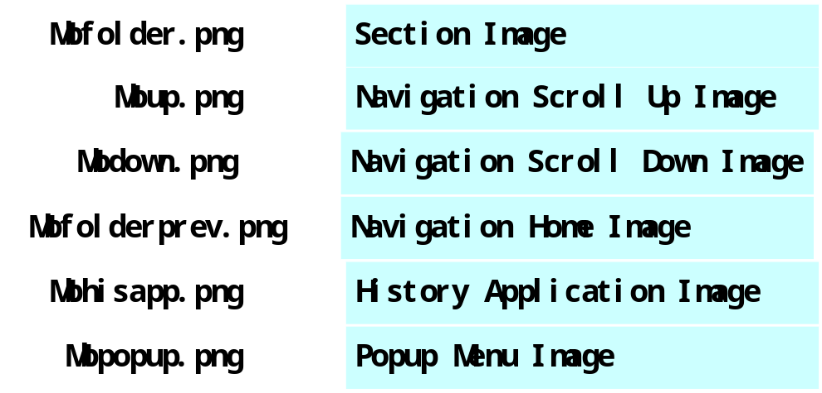
OpenMoko Quick Menu Launch

Layout Components
(TBD)
It need to be modify according to last conference issue result. It is same as main menu launch.

Architectural Details
- This picture shows an overview about the main menu desktop application.
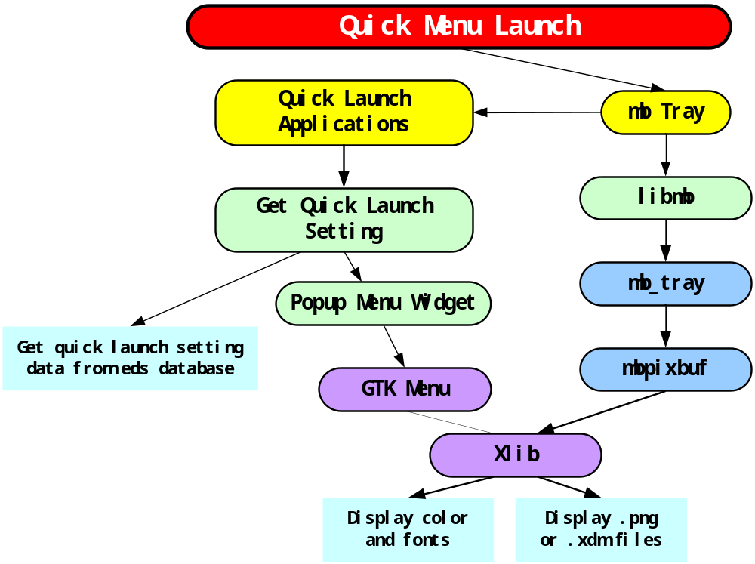

Implementation Recommendation
- Technically, it will be a panel plug-in application residing in the right of main menu icon of the Top Panel. Mbtray (one function of libmb) allows you to add/remove one plug-in in Top Panel.

- On tap quick launch icon, we shall get quick launch setting from EDS, and then create a new popup menu with GtkMenu.

Interface Introduce
- Inside Interface
  - Libmb
  - mbtray API
  - mbpixbuf API
  - Quick Launch Button
【On Tap】
        - Open quick launch menu with one list.
【Motion】
        - Show hits.
【Other】
- Nothing to do
  - Popup menu
【On Tap】
        - Close popup menu.
        - Execute application.
【Other】
- Nothing to do

- Outside Interface
  - libmokosetting
  - getCurrentQuickLaunchNameList
// get current all quick launch application’s name list.
  - dbus
  - notify footer menu information status

Flow Chart

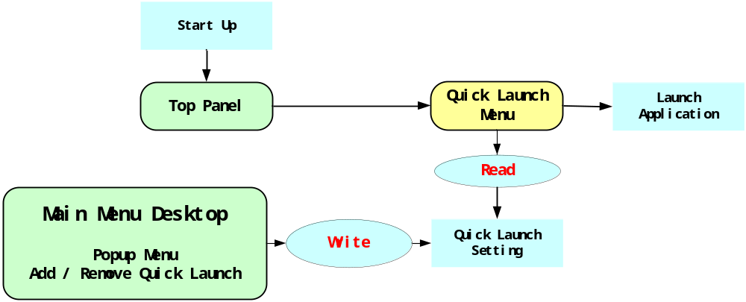

Questions and Answers
Q1: How to store quick launch setting and define setting format?
A1: I suggest to refer to main menu. We can define a special vfolder, for example qfolder, and then define one standard .directory files. In .directory files, we can get all quick launch applications. Each quick launch application has one standard .desktop files.

Image Resources
OpenMoko Main Menu Launch

Layout Components
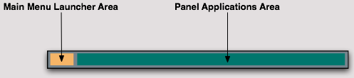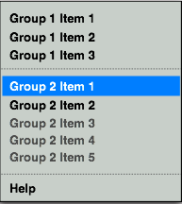
Architectural Details
- This picture shows an overview about the main menu launch plug-in and their dependencies with Top Panel.
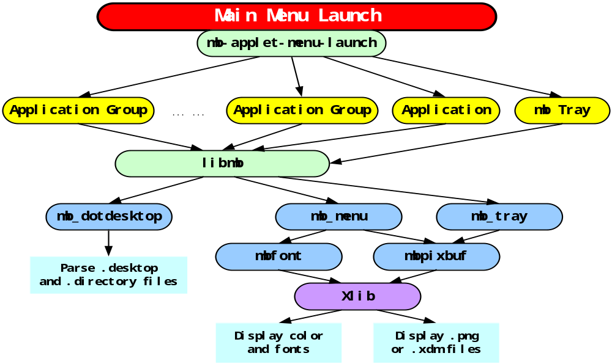
Implementation Recommendation
- Technically, it will be a panel plug-in application residing in the upper left corner of the Top Panel. Mbtray (one function of Libmb) allows you to add/remove one plug-in in Top Panel.
- Mb-applet-menu-launch is a good idea. It can be as main menu launch base implementation.
- All “Application Group” and “Application” are depended .desktop and .directory files. Group name is decided by “Category” section in .desktop files. Group or application is decided by “Type” section. They are usually included in “/usr/share/applications” directory. Libmb has provided some APIs to parse .desktop files.
- All menus and menu items will be displayed by mbpixbuf (one function of Libmb).
- In finger mode, man menu launch will be display main menu desktop

Interface Introduce
- Inside Interface
  - Libmb
  - mbdotdesktop API (Freedesktop Standards utility)
  - mbtray API
  - mbmenu API
  - mbpixbuf API
  - mbfont API
  - getCurrentSystemScreenMode
Poll mode setting, distinguish finger mode or style mode
  - Main menu Launch Button
【On Tap】
        - Open main menu
【Motion】
        - Show hits.
【Other】
- Nothing to do
  - Popup menu
【On Tap】
        - Close popup menu.
        - Execute application.
【Other】
- Nothing to do

- Outside Interface
  - dbus
  - notify footer menu information status

Flow Chart
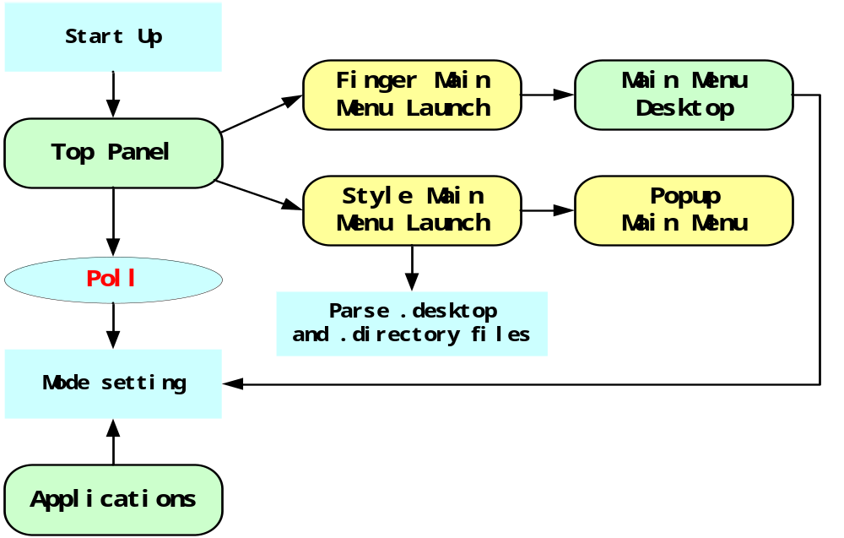

Questions and Answers
Q1: Mbmenu is draw with pixbuf based Xlib directly. It’s color is fixed in code. You can change menu font or menu item’s icon, but not change menu’s font and background color. How about theme?
A1: I suggest we need two theme. One is GTK theme. Another is OpenMoko theme.

Q2: If we redraw menu with Popup menu widget based GtkMenu and GtkMenuItem, we don’t think about theme. But we need rewrite a lot of code in mb-applet-menu-lanuch plug-in.
A2: I suggest we use mbmenu before 2006/11/02.

Q3: Because main menu launch must switch between finger and style mode, How to distinguish the two modes?
A3: I suggest when each application startup, the application set mode setting. This is a system argument stored in database or setting file. Top panel will poll the setting, then switch main menu launch icon.

Image Resources
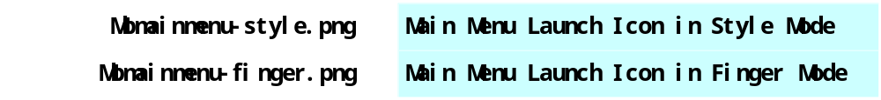
Request and Condition
